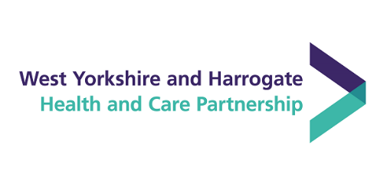
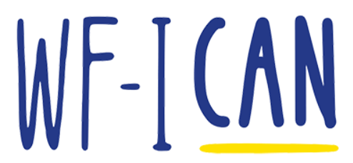
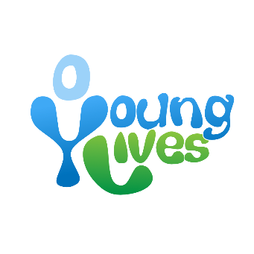

PARTICIPANT INFORMATION SHEET
for 16 – 25 year olds / parents and carers

Project title
Exploring what makes a trauma informed experience for young people moving to adult mental health services in Wakefield.

Being trauma informed means working to understand how difficult life experiences can impact people’s behaviours and their health and wellbeing in different ways. Gaining understanding of this helps workers respond and treat people in a way that helps them to feel as safe and comfortable as possible.

Invitation
You are being invited to take part in a research project to improve the knowledge base around what it’s like for young people moving to adult mental health services from CAMHS. Before you decide whether to take part, it is important for you to understand why the research is being done and what it will involve. Please take time to read the following information carefully. Ask questions if anything is not clear or you would like more information.

What is the purpose of the project?

The purpose of the Young People’s Community Builder project is to gain further understanding of young people's experiences coming to the end of their support within Children and Adolescent Mental Health Services (CAMHS), and also those moving to adult mental health services. The aim is to find out what is working well and identify areas along this process that need strengthening, whilst co-creating with young people possible suggestions that can help make the process the best it can be.

This understanding will be gathered through collecting lived experience accounts from young people, parents and carers, along with information and experiences shared by practitioners working with young people. Participants can take part either through in person consultation, or by completing an online questionnaire. The data and findings from this project will be published in a report in May 2024. The report will showcase what is currently working well in Wakefield and the needs of young people in regards to those coming to the end of their support with CAMHS, as well as those moving to adult mental health services. It will also include suggestions for possible solutions co-created with young people.

This particular research is part of the Adversity, Trauma and Resilience improving population health programme launched by the West Yorkshire Health and Care partnership. The programme is exploring what is needed to create trauma informed services and organisations with an ambition to make West Yorkshire a trauma informed and responsive system by 2030. More information can be found at www.wypartnership.co.uk

Why have I been invited to participate?
You have been invited to take part in this research project because you are either:
- Between the ages of 16 – 25 and have had, or currently getting, support for your emotional and mental health.
- Someone who has recently experienced moving out of Child and Adolescent services at the age of 18 and into Adult Mental Health Services.
- A parent or carer of a young person who has experienced / is experiencing moving out of Children and Adolescent services and into Adult Mental Health Services.

What does taking part involve?
Amy will have a conversation with you about your experiences of moving between CAMHS and Adult MH Services. At points during the meeting Amy will ask you to reflect on how your experience can inform improvements for young people like yourself who are also moving between CAMHS and adult services. Throughout the meeting Amy will highlight areas for further reflections and make notes on points you both feel are important. No audio or video will be recorded from the meeting.

If you are a parent or carer, you will be asked how this experience was for you supporting someone going through this process, what support you felt worked well, and any areas you feel could have been strengthened to make the process better.

There will also be the option to share your experiences by filling out an online form if this is easier for you.

Unless you are filling out the online questionnaire, interviews will take place in location and at a time that it is most comfortable for you and will last approximately 1 hour.

What are the possible benefits of taking part?
By sharing your experiences, your voice will be helping the Community Builder to capture a real picture of what it’s like for young people, and for the parents and carers of young people, coming to the end of Children and Adolescent Mental Health services, as well as what it’s like for those starting Adult Mental Health services. The aim of the Community Builder is to find out what the needs are of young people in a variety of circumstances going through this process, and co-create a series of suggestions around need and how to implement changes, which will be shared with commissioners and service providers in an easy to understand report. This is an opportunity to take part in making positive changes for young people moving to adult mental health services.

are there any possible risks or disadvantages in taking part?
Risks in taking part are low, however, the research process has been designed to support participants if you feel distressed during the meeting. The interview can be stopped at any time. The Community Builder will provide time for a debrief afterwards if needed to make sure you feel comfortable and safe and you will also be signposted to services to go to for support if needed.

How Will My Data Be Looked After during the project?
All your data will be processed and stored in accordance with the General Data Protection Regulation (GDPR) along with the Data Protection Act 2018 (DPA). The project will be also be guided by and adhere to Young Lives Consortium’s guidance and regulations.

What will happen to my data?
Amy won’t hold any identifying personal information of yourself. The notes that Amy takes away during the meeting will be co-created during the meeting. Audio and video recordings will not be used and consent for any quotes taken will be requested during the meeting.

What if i want to withdraw from the project?
You have the right to withdraw from the meeting at any time. You also have the right request that notes made during the meeting not be used in the research up to 24 hours after the meeting.

What will happen with the results of the research project?
The results of this research project will be published in a summary report that will be made available to the public on www.younglives.net and www.wf-i-can.co.uk

The Community Builder may also use the notes from the meetings when developing training workshops and presentations for practitioners that focus on young people coming to the end of their support with CAMHS, and/or moving to adult mental health services. Quotes from your interview may be used in these outputs but will remain anonymous.

Contact for Further Information
If you want to arrange a time to meet to share your experiences, or have any further questions, please contact the Young People’s Mental Health Community Builder who is leading on this project:
Amy Charles
amy@ylc.org.uk
07708471830

If you have any concerns about the way in which the project has been conducted, wish to make a complaint, or want to share any positive feedback, you can contact the CEO of Young Lives Consortium:

Emily Castle
emily@ylc.org.uk
07835817480
Young Lives Consortium
Lightwaves Leisure Centre
Lower York Street
Wakefield
WF1 3LJ
Thank you for taking time to read this Participant Information Sheet.

Date: 9th August 2023

